MULTISITE GRANT MANAGEMENT SYSTEM

Internal Proposal Evaluation

User Guide Document

-MGMS Ver. 1.6-

Version History
Date | Description
10-Jan-2010 | First Draft

Table of Contents

Version History 2
1 Introduction 5
1.1 Purpose 5
2 Internal Proposal Evaluation 5
2.1 Initial Administrative Functions 7
2.1.1 Adding new users - reviewers: 7
2.1.2 Creating approval Authorities: 8
2.1.3 Upload Pre-proposal Application form 9
2.1.4 Add Proposal Category 10
2.2 Submission of Pre-proposal by staff members 11
2.3 Proposal Authority Mapping 12
2.4 Pre – proposal Review 13
2.5 Submission of Full proposals by staff members 16

Table of Figures

Figure 1: Admin - Add new user 7
Figure 2: Admin - User List 7
Figure 3: Admin - Create Access Permission 8
Figure 4: Admin - Add approval authority 8
Figure 5: Admin - Add members to approval authority 9
Figure 6: Admin - Edit approval authority 9
Figure 7: Admin - upload pre-proposal application 10
Figure 8: Admin - Add Proposal Category 10
Figure 9: Staff - Add new proposal 11
Figure 10: Staff - Application form 11
Figure 11: Staff - Save/submit pre-proposal 12
Figure 12: Staff - Pre proposal List 12
Figure 13: Staff - Pre proposal review status 12
Figure 14: Admin - Assign proposal to Approval Authority 13
Figure 15: Admin - Edit proposal-approval authority map 13
Figure 16: Reviewer - Pre proposal List 13
Figure 17: Reviewer - Pre proposal details 14
Figure 18: Reviewer - Pre proposal status 15
Figure 19: Reviewer - Pre proposal - view past reviews 15
Figure 20: Staff - Pre proposal status tracking 15
Figure 21: Staff - Pre proposal review status 15
Figure 22: Staff - Full proposal List 16
Figure 23: Staff - Full proposal upload 16
Figure 24: Staff - Full Proposal List - Status 16
Figure 25: Staff - Full proposal Review Status details 17
Figure 26: Reviewer - Full Proposal - View past reviews 17

Introduction

Purpose

This document provides the step-by-step instructions for the various activities associated with proposal evaluation within an organization using the Multisite Grant Management System application.

This is a ‘living document’ and the specification will change, continuously, as the project proceeds. More details will be added and the existing information edited as the requirements, architecture and design evolve in the course of the project.

Internal Proposal Evaluation

The business flow is as follows:

- Multiple staff members can create and submit pre-proposals to the organization.
- The pre-proposal details are captured on a fixed format which is particular to the institution and uploaded/maintained by the administrator.
- Each of the submitted pre-proposals may go through multiple levels of evaluations, each of which is done by one or more reviewers.
- Currently, the routing of pre-proposals is not pre-set and for each pre-proposal, the administrator can assign a separate evaluation chain.
- There is also provision to set a conditional restart order whereby a different routing path can be set if during the regular process, there has been revert.
- The staff members can track the status of their pre-proposals in their login.
- Corresponding to the approved pre-proposals, full proposals can be submitted by the staff members. These will again go through the same evaluation process as above.

The workflow is presented below:

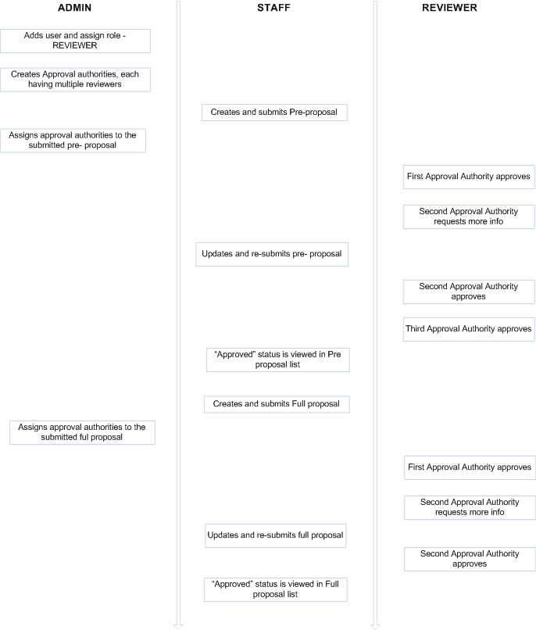

Initial Administrative Functions

Adding new users - reviewers:
A new role “Reviewer” has been added to GMS. The reviewers can be added by the Administrator through Add User page and the role can also be assigned here.
Figure 1: Admin - Add new user
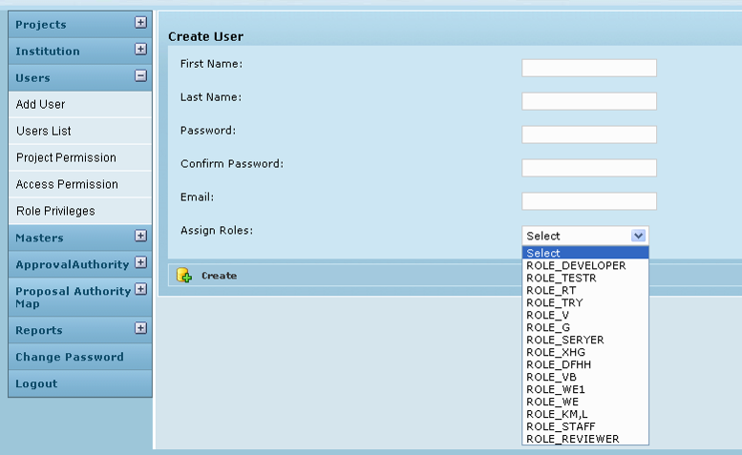
The reviewers created are displayed in the User List.
Figure 2: Admin - User List
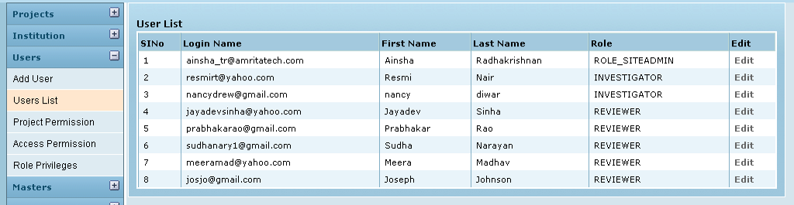

The privileges for the role “reviewer can be saved in the Access Permission page.
Figure 3: Admin - Create Access Permission
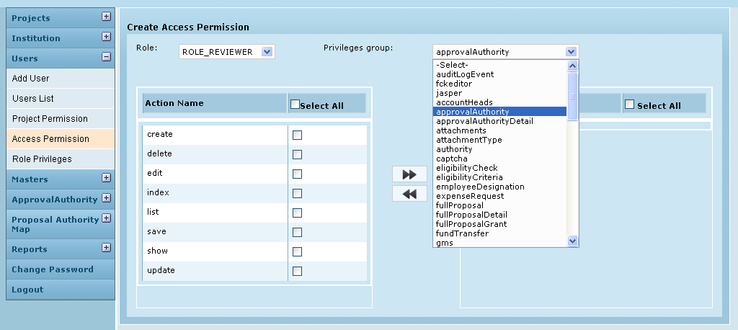

Creating approval Authorities:
On the left menu panel, the administrator clicks on Approval Authority menu. It expands to display the sub menu – Add Approval Authority
On clicking Add Approval Authority, the page below opens up. Here each group of approving persons at the institution is registered. Further, for each approval authority, the members are also added
Figure 4: Admin - Add approval authority
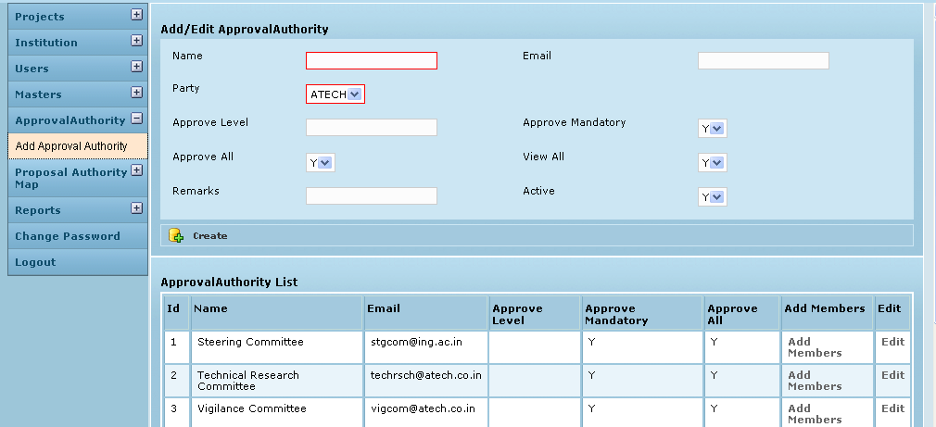
The fields bordered in red are mandatory.
The personal details are: Name of the group, group e-mail ID and Institution. Further, the Approve Mandatory field decides if the particular group’s approval is mandatory and it is set to “Y” (Yes) by default. View All is set to “Y” (Yes) by default which indicates that the members of this group are privileged to view all proposals even if they don’t get to review them. Setting a group inactive here will result in removing the group from all user options. It is then deemed to be non-existing.
In the Approval Authority List, for each line item (approval authority) , clicking on Add Members opens the page below, where members can be added to/removed from each Approval authority. The existing reviewers are displayed in the table on the right (faculty) from which selection can be made.
Figure 5: Admin - Add members to approval authority
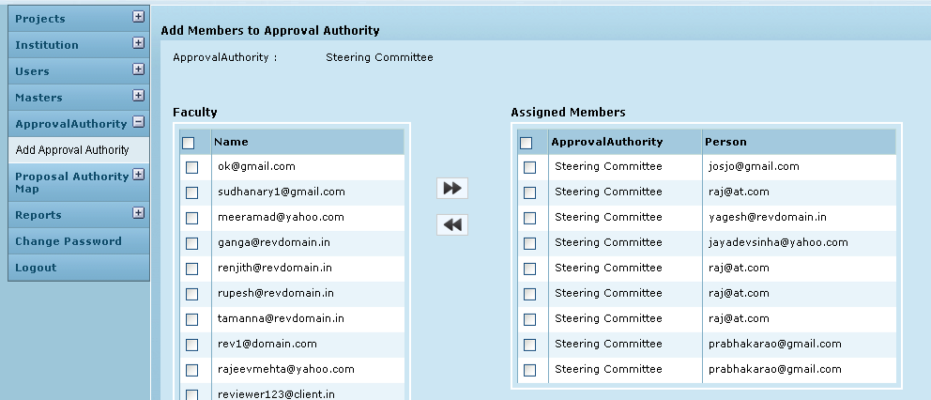
In the Approval Authority List (Fig 4), for each line item (approval authority), clicking on Edit, opens the page below, where any modification can be made.

Figure 6: Admin - Edit approval authority
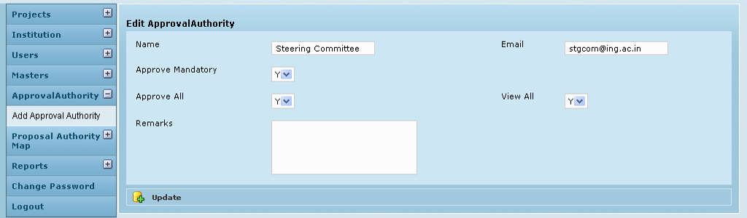

Upload Pre-proposal Application form
The admin logs in the system and on the left menu panel, clicks Proposal Authority map. When the menu expands, the admin clicks on Upload Proposal Form to open the screen shown below. Here, the admin can browse and upload the form used by the institution to capture details of the proposal which constitutes the pre-proposal.

Figure 7: Admin - upload pre-proposal application
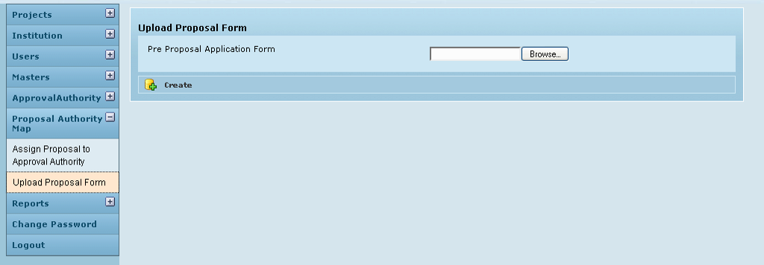

Add Proposal Category
The Admin has to save the various proposal categories in the GMS application for users (staff) to select from while creating their proposals. Examples for category are Research, e-content, infrastructure, network etc. This is done in the Masters module, sub menu – Proposal Category

Figure 8: Admin - Add Proposal Category
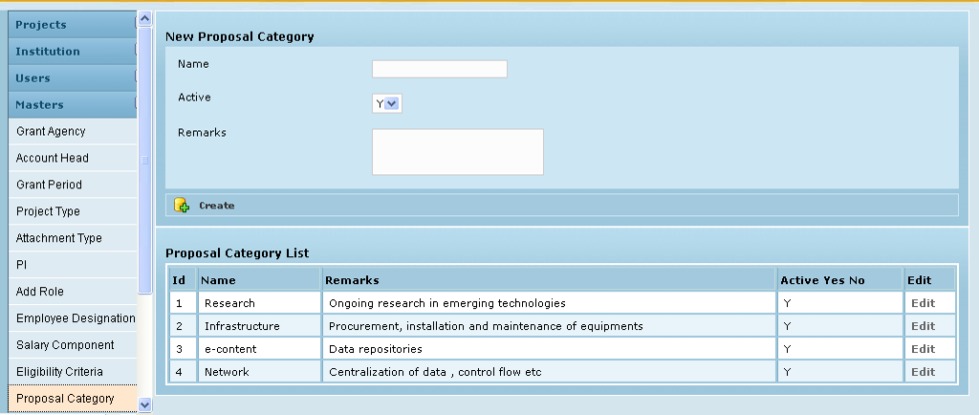

Submission of Pre-proposal by staff members
The staff includes those users who submit pre-proposals /proposals for evaluation. The Staff logs into the application to create and submit pre-proposals to own institution for review. After logging in, user clicks Pre proposal Menu on the left panel and then clicks Add New Proposal. The page below is opened.
Figure 9: Staff - Add new proposal
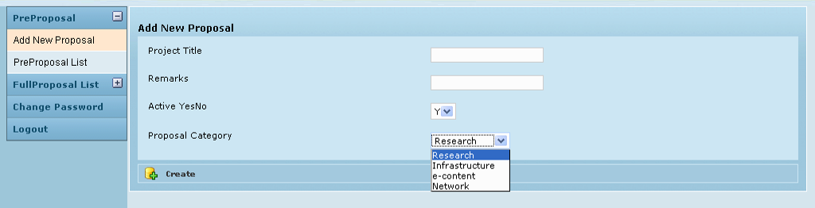
On clicking Create, the institution’s pre-proposal application form is opened for the Staff to fill up the pre-proposal details:
Figure 10: Staff - Application form
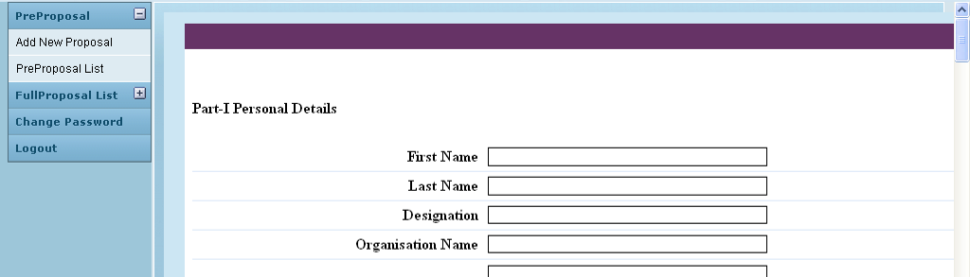
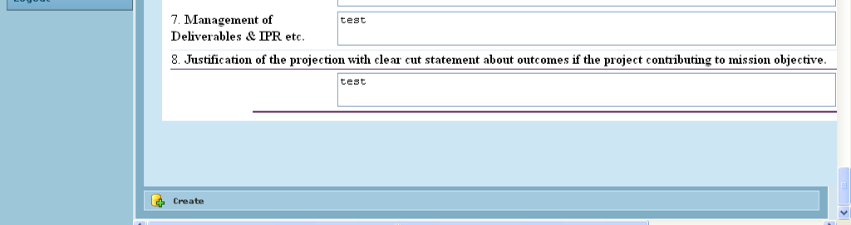
After filling in the details, on clicking Create, the user is given options to – save the document as draft or to submit to authorities for review.
Figure 11: Staff - Save/submit pre-proposal
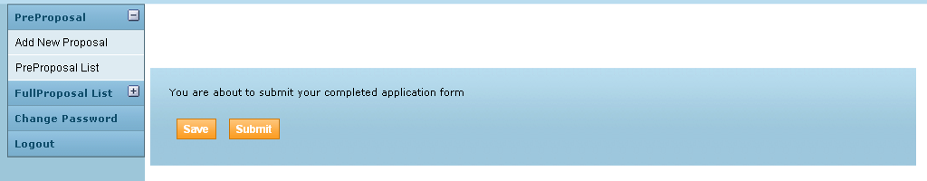

The screen below shows the Staff‘s list of pre-proposals which have been submitted so far and their status. ‘Reviewing” status indicates that the pre-proposal submitted is under review. If the user had chosen to save as draft then this field would have displayed “Saved”.
Figure 12: Staff - Pre proposal List
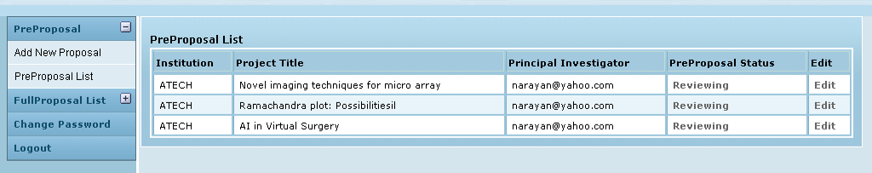
Edit button allows editing and re-submitting of the pre-proposals.
When in “Reviewing” status, clicking on “Reviewing” will open the following page:
Figure 13: Staff - Pre proposal review status
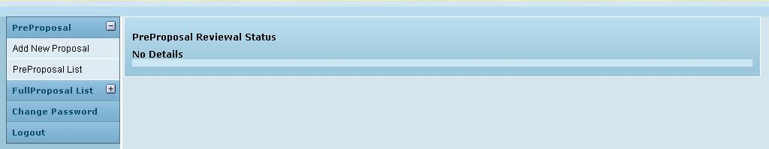
Currently there are no details shown. Once the admin assigns the pre-proposal to the approval authorities, sets the start order, restart order etc, those details are shown here.
This process is described below:

Proposal Authority Mapping

The admin logs in the system and on the left menu panel, clicks Proposal Authority map. When the menu expands, the admin clicks on Assign proposal to approval authority sub menu. The screen is shown below:

Figure 14: Admin - Assign proposal to Approval Authority
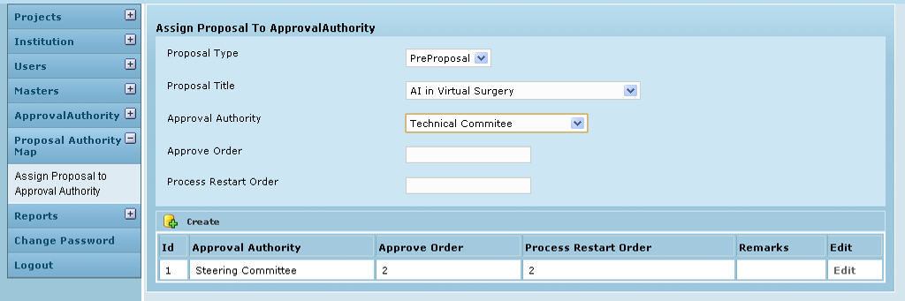
The details can also be edited at a later time.
Figure 15: Admin - Edit proposal-approval authority map
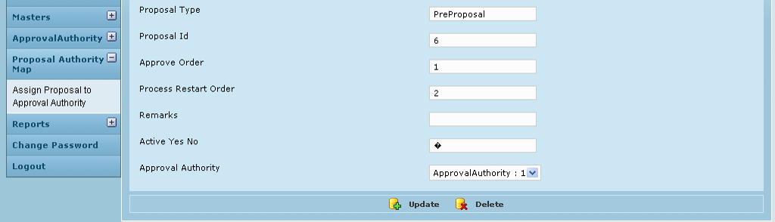
Once the admin saves the above details, the pre-proposal details get populated for each member of the approval authorities to whom the specific pre-proposal was assigned. A sample screen of a reviewer is shown below in Fig 17:

Pre – proposal Review

The reviewer log in, clicks Pre proposal menu on the left and when the menu expands, clicks Pre proposal Approval. The list of proposals to be reviewed by this reviewer at various evaluation levels is displayed here.
Figure 16: Reviewer - Pre proposal List
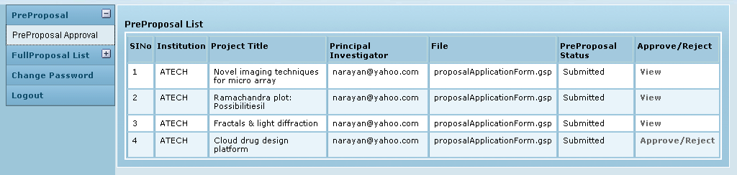
If, for a particular pre-proposal, this reviewer belongs to the approval authority of the first level (Approve order – 1), then in the Approve /Reject column the corresponding status will be “Approve/Reject”. On clicking this status label, the pre-proposal is opened and the reviewer is provided with 3 buttons – Accept, Need more info, Reject.
But if the reviewer belongs to any other authority level, then till the pre-proposal passes through the other levels before his own, the status in the Approve /Reject column will be “View” for this reviewer (and all others at this authority level). On clicking View, the pre-proposal form can be opened and viewed only.

Figure 17: Reviewer - Pre proposal details
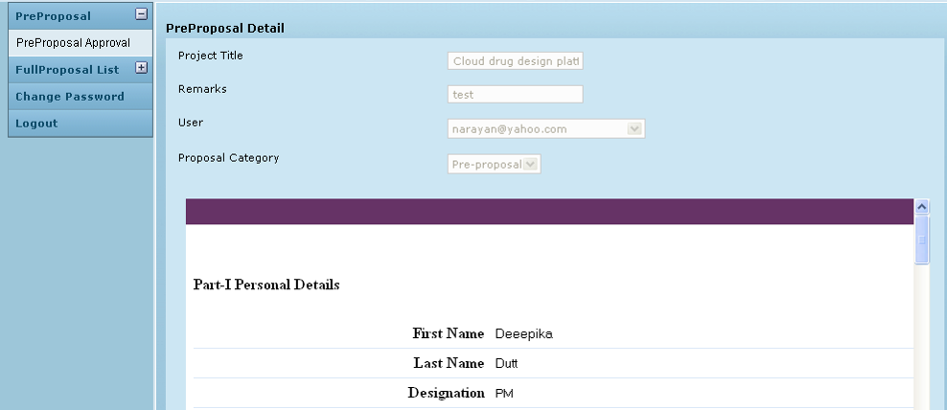
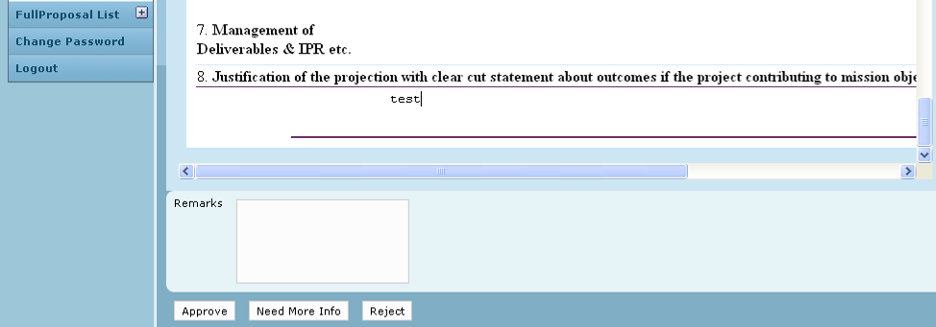

The reviewer has been provided with a text area to input comments.
Once a suitable status (Approved) is selected, the line item disappears from the specific reviewer’s list and the line item populates the reviewers’ lists at the next authority level.
If “Need more info” status is selected then the line item returns to the Staff’s list. The Staff can resubmit after adding the required details and the chain now follows the Process Restart order.
Figure 18: Reviewer - Pre proposal status
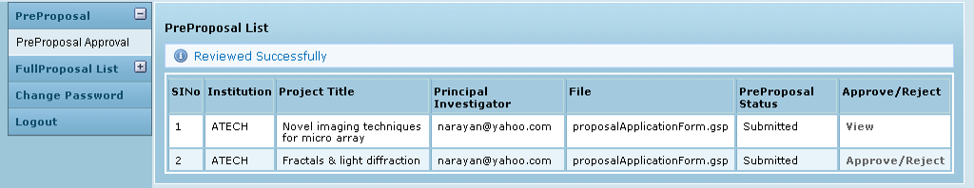
As can be seen below, the last line item in the table has an “Approved” status
The reviewer can view the proposals he has reviewed in the past on a different page:

Figure 19: Reviewer - Pre proposal - view past reviews
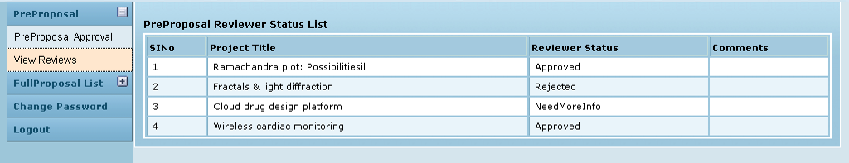
Meanwhile, the staff person can track the review status in his log in, in the Pre Proposal List.

Figure 20: Staff - Pre proposal status tracking
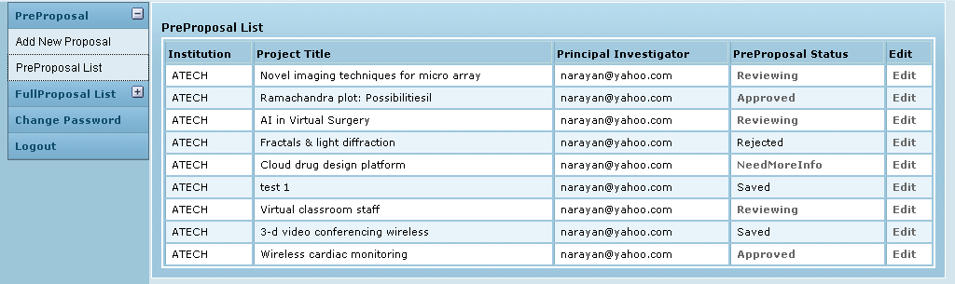
Post review, clicking in the status for any line item, displays details as shown below:
Figure 21: Staff - Pre proposal review status
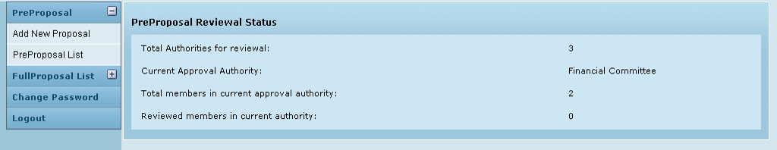

Submission of Full proposals by staff members

The approved pre-proposals details also get automatically populated in the Full Proposal List for the Staff. In figure 18, 2 pre-proposals were approved. The same 2 are now displayed in Fig 22 below.
Figure 22: Staff - Full proposal List
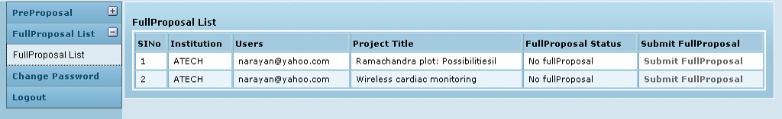
By clicking Submit Full proposal for a line item here, the staff will open the proposal uploading page as shown below in Figure 23. The Full Proposal Status displays No Full Proposal for both the line items indicating that proposals have not been uploaded yet. By clicking Submit Full Proposal for each line item, screen as shown in Fig 23 below can be opened. Here the proposal can be uploaded and saved or submitted (just as in the case of pre-proposal)
Figure 23: Staff - Full proposal upload
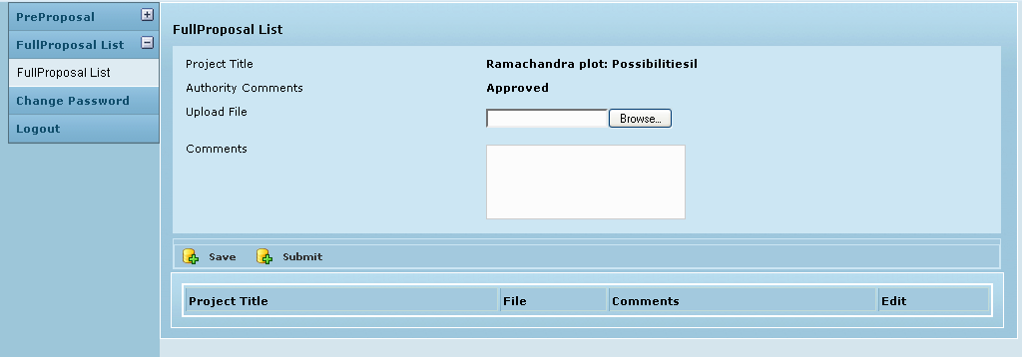

Once the proposals are submitted, the status in Full Proposal List – Full Proposal Status column changes to Reviewing.
Figure 24: Staff - Full Proposal List - Status
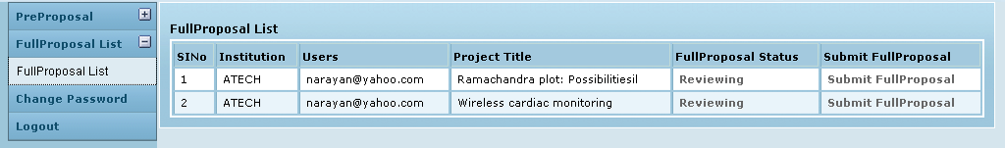
Here onwards the process is same as that for pre-proposal. The admin maps the approval authorities for the submitted full proposals and so the details get populated as lie items for the various reviewers.
As the review happens the staff member can view the status of his full proposal. A sample screen is given below:
Figure 25: Staff - Full proposal Review Status details
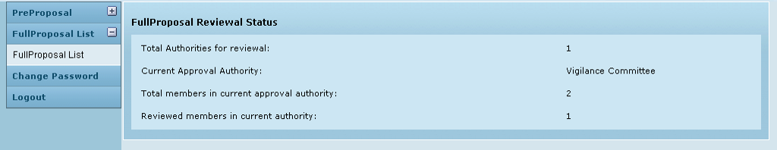

The routing for approval happens as per the given process and restart orders. Finally the approved /rejected status is displayed in the Full Proposal List for the staff to see.

The reviewer can view the past review results at:

Figure 26: Reviewer - Full Proposal - View past reviews
